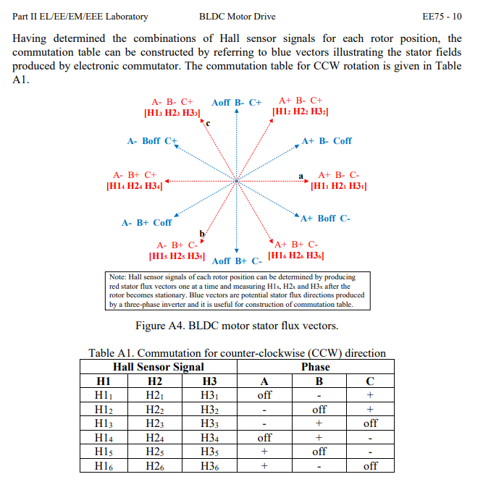

CCW (Counter Clock Wise) Commutation table to be coded in:
hallA | hallB | hallC | phaseA | phaseB | phaseC
0 | 0 | 1 | 0 | -1 | +1
0 | 1 | 1 | -1 | 0 | +1
0 | 1 | 0 | -1 | +1 | 0
1 | 1 | 0 | 0 | +1 | -1
1 | 0 | 0 | +1 | 0 | -1
1 | 0 | 1 | +1 | -1 | 0

CW (Clock Wise) Commutation table to be coded in:
hallA | hallB | hallC | phaseA | phaseB | phaseC
1 | 0 | 1 | 0 | -1 | +1
1 | 0 | 0 | +1 | -1 | 0
1 | 1 | 0 | +1 | 0 | -1
0 | 1 | 0 | 0 | +1 | -1
0 | 1 | 1 | -1 | +1 | 0
0 | 0 | 1 | -1 | 0 | +1

